**An internship report on**

**MARKETING INTERN**

**AT**

**SHREE RAM OIL MILL**

**Submitted To Bengaluru City University**



**In partial fulfilment for the award of Bachelor of Business Administration Degree**

Under the Guidance of

**Dr. GEETHA NAGARAJU**

**PRINCIPAL**

# INTERNSHIP CERTIFICATE

# DECLARATION BY THE STUDENT

I hereby declare that the Internship Report prepared by me is the result of the original work undertaken at **SHRI RAM OIL MILL** carried out by me under the guidance of Principal partial fulfilment for the award of Bachelor of business administration by Bengaluru City University.

I also declare that this report is the outcome of my own efforts and that it has not been submitted to any other university or Institute for the award of any other degree or Diploma or Certificate.

**Place:** BENGALURU **:**



## CERTIFICATE BY THE COLLEGE

Certified that**)** is a student of final year Bachelor of Business Administration of East West School of Business Management, Bengaluru-64. Has submitted An Internship Report, prepared in partial fulfilment of the requirements for the award of the Degree of "Bachelor of Business Administration of Bengaluru City University and has not formed a basis for the award of any other Degree or Diploma of any other University.

**PLACE:** BENGALURU  **DATE: PRINCIPAL**

## CERTIFICATE BY HEAD OF THE DEPARTMENT

Certified that is a student of final year Bachelor of Business Administration of East West School of Business Management, Bengaluru-64. Has submitted Internship Report, prepared under the guidance of faculty of our college in partial fulfilment of the requirements for the award of the Degree of "Bachelor of Business Administration of Bengaluru City University and has not formed a basis for the award of any other Degree or Diploma of any University or Institution.

**ASST. HEAD OF THE DEPARTMENT**

## SUPERVISOR’S CERTIFICATE

This is to certify that the content of this report on “**MARKETING OF CUSTOMER RELATIONSHIP”** carried out by bearing Register no. is a Bonafide work carried out by the student under my supervision during the academic year 2023-24 in partial fulfilment for the completion of VI Semester Bachelor of Business Administration, of Bengaluru City University.

**Place:** BENGALURU

**Date: PRINCIPAL**

**Signature of the Supervisor’s**

## ACKNOWLEDGEMENT

I take this as an opportunity to express my profound gratitude to all who have been significant contributors to this Internship Report.

I express my gratitude to Chair Person, East West School of Business Management for support in carrying out the internship.

I express my deepest sense of gratitude to, Principal, East West School of Business Management for her constant support and for sparing her valuable time and guiding in the successful completion of the report. She is also supervisor, who gave valuable insights for carrying out the internship successfully.

I am thankful t**,** Head of Department of Management, East West School of Business Management, for her support, guidance and encouragement.

I also thank the company **SHRI RAM OIL MIL** for their support in carrying out internship at their esteemed organization.

**Date: Place:** Bengaluru

Signature of the Student

## TABLE OF CONTENT

|  |  |  |
| --- | --- | --- |
| **Particulars** | **Topic** | **PAGE NO** |
| Chapter - 1 | **INTRODUCTION OF THE STUDY**    1.1 Introduction  1.2 Objective of the study  1.3 Scope of the study  1.4 Limitations of the study  1.5 Method of data collection | **1-3**    1  1  2  3  3 |
| Chapter - 2 | **PROFILE OF THE COMPANY**    2.1 Brief Profile  2.2 Brief Introduction of the factory  2.3 Methodology of the study  2.4 Vision of The Factory  2.5 Mission of The Factory  2.6 Members of The Factory  2.7 Quality Assurance  2.8 Team of The Factory  2.9 Infrastructure  2.10 Product Services | **4-15**    4  5  5  8  8  8  9  9  9  9 |
| Chapter - 3 | **WORKING EXPERIENCE IN MARKETING**    3.1 Work undertaken in the Factory  3.2 Sales Department  3.3 Types of Sales  3.4 Manufacturing Department  3.5 Key Functions and Responsibility  3.6 Different Types of Manufacturing  3.7 Selling process  3.8 Advantages of sales  3.9 Disadvantages of sales  3.10 Problem on sales | **16-32**      16  19  21  22  23  24  26  27  29  31 |
| Chapter - 4 | **SWOT ANALYSIS**    4.1 SWOT Analysis of the Factory  4.2 Work experience in the factory  4.3 Working Environment  4.4 Learning Outcome | **33-39**    33  36  37  36 |
| Chapter - 5 | **FINDINGS AND CONCLUSION**    5.1 Findings  5.2 Conclusion | **40-41**    40  41 |

## TABLE OF FIGURES

|  |  |  |  |
| --- | --- | --- | --- |
| **SL No.** | **Description** | **Figure Number** | **Page no.** |
| **01** | Logo of the company | 1 | 4 |
| **02** | Profile of the company | 2 | 4 |
| **03** | Oil crushing machine-1 | 3 | 10 |
| **04** | Oil crushing machine-2 | 4 | 10 |
| **05** | Coconut crushing machine-1 | 5 | 10 |
| **06** | Coconut crushing machine-2 | 6 | 10 |
| **07** | Oil filter machine-1 | 7 | 11 |
| **08** | Oil filter machine-2 | 8 | 11 |
| **09** | Oil storing container | 9 | 12 |
| **10** | Interaction with customer | 10 | 12 |
| **11** | Seeds cleaning machine-1 | 11 | 13 |
| **12** | Seeds cleaning machine-2 | 12 | 13 |
| **13** | Grinding machine-1 | 13 | 13 |
| **14** | Grinding machine-2 | 14 | 13 |
| **15** | Ground nut oil | 15 | 14 |
| **16** | Coconut oil | 16 | 14 |
| **17** | Safflower oil | 17 | 14 |
| **18** | Mustard oil | 18 | 15 |
| **19** | Niger oil | 19 | 15 |
| **20** | Packaged oil bottles | 20 | 15 |
| **21** | Packaged oil bottles | 21 | 15 |
| **22** | Sales department | 22 | 19 |
| **23** | Types of manufacturing | 23 | 25 |
| **24** | Selling process | 24 | 27 |
| **25** | Doing sales | 25 | 32 |
| **26** | Swot analysis | 26 | 33 |
| **27** | Swot analysis | 27 | 34 |
| **28** | Working office | 28 | 35 |
| **29** | Flour crushing office | 29 | 35 |
| **30** | Storage area | 30 | 35 |
| **31** | Customer Purchase area | 31 | 35 |
| **32** | Employees experience | 32 | 36 |
| **33** | Learning outcome | 33 | 39 |

## SHREI RAM OIL MILL ACTIVITY LOG FOR THE INTERNSHIP

|  |  |  |
| --- | --- | --- |
| **DATE & DAY** | **BRIEF DESCRIPTION OF THE DAILY**  **ACTIVITY** | **TIME** |
| 28-09-2023 | Had an brief explanation of the working process of company and daily activities which needs to be handled | 9:30 AM –  6:00PM |
| 29-09-2023 | Got the training of the interaction with how to talk with customers and how to handle the situation with them | 9:30 AM –  6:00PM |
| 30-09-2023 | They thought us the marketing process of the company and their way of getting into the business | 9:30 AM – 6:00PM |
| 01-10-2023 | Had an training of production process of the edible oil of the company | 9:30 AM – 6:00PM |
| 02-10-2023 | Made my first interaction with the customer in selling of the product | 9:30 AM – 6:00PM |
| 03-10-2023 | There was a process of learning how the raw materials and goods are brought and stored | 9:30 AM – 6:00PM |
| 04-10-2023 | They gave training on how the packaging and distribution takes place in the company | 9:30 AM – 6:00PM |
| 05-10-2023 | Had the customer interaction in calls and booking the items customer needs to their address through online process | 9:30 AM –  6:00PM |
| 06-10-2023 | Got an brief learning of the products to talk with customers and explaining them about the product | 9:30 AM – 6:00PM |
| 07-10-2023 | Went out to meet new customers and influencing them to buy the product oh the company and making them understand the  benefits of it | 9:30 AM –  6:00PM |
| 08-10-2023 | Did the production of edible oil because it was out of stock to sell for customer | 9:30 AM – 6:00PM |
| 09-10-2023 | Had an packaging and stocking of finished goods for the selling of the product | 9:30 AM –  6:00PM |
| 10-10-2023 | Did the selling of items with good interaction with customers and got an good feedback from the manager for the work done | 9:30 AM –  6:00PM |
| 11-10-2023 | Handled the good selling process and did well influence for customers in explaining and making them to buy the product | 9:30 AM –  6:00PM |
| 12-10-2023 | Got an good learning of marketing skills and strategies from the CEO of the company | 9:30 AM – 6:00PM |
| 13-10-2023 | Did the selling of items through online and offline for customers | 9:30 AM – 6:00PM |
| 14-10-2023 | Distribution of finished items was done for different stores throughout the area | 9:30 AM – 6:00PM |
| 15-10-2023 | Last day got an test of our skills and strategies in customer relationship of marketing and did well with good result and gained an ample of experience from this internship | 9:30 AM – 6:00PM |

**SIGNATURE OF COMPETENT AUTHORITY WITH SEAL**

## CHAPTER – 1 – INTRODUCTION OF THE COMPANY

### 1.1 INTRODUCTION

Internship program is essential for all BBA students, because it helps him or her to acquire real life situation. SHRI RAM OIL MILL. which is one of the leading best manufacturing factories in RR nagar Bangalore.

Established with a vision to redefine the sales industry, they brings together a team of seasoned professionals with a wealth of experience and a passion for delivering results. With our proven track record of driving revenue growth and building lasting client relationships, we stand as your trusted partner in achieving your sales objectives.

What sets us apart is our unwavering commitment to service excellence. From initial consultation to ongoing support, we prioritize your satisfaction every step of the way. Our dedicated team works tirelessly to understand your specific goals, challenges, and market dynamics, allowing us to craft bespoke solutions that deliver measurable results.

At Shriram oil mill, innovation is at the core of everything we do. Leveraging the latest technologies and best practices, we empower our clients to stay ahead of the competition and capitalize on emerging opportunities. Whether you're a small startup or a global enterprise, we have the expertise and resources to propel your sales efforts to new heights.

Join us on the journey to success and experience the difference that Shriram oil mill can make for your business. Together, let's unlock new possibilities, drive growth, and achieve unparalleled success in the everevolving world of sales.

Internship report is one of the parts of completing BBA degree of the department of Business Administration, Bengaluru City University. This report is on The Process and Implementation of marketing. It was a chance for me to learn about the Manufacturing and Marketing procedure of the factory.

### 1.2 OBJECTIVE OF THE STUDY

**General Objective:**

The general objective of the study is to understand the marketing Process and Implementation system of SHREE RAM OIL MILL.

**Specific objectives:**

Specific objectives of the study are summarized below:

* At Shree ram oil mill, their primary objective is to serve as a catalyst for the success and growth of businesses worldwide. We aim to achieve this by offering a comprehensive suite of services and solutions that are tailored to meet the diverse needs of our clients across various industries.

* Our mission is to empower businesses with the tools, resources, and expertise they need to thrive in today's rapidly evolving market environment. We strive to be more than just a service provider; we aspire to be a strategic partner that businesses can rely on for guidance, support, and innovation.

* Through our commitment to excellence, we endeavor to deliver measurable value to our clients, whether it's through increasing revenue, optimizing operations, enhancing customer satisfaction, or achieving other key objectives. We understand that every business is unique, which is why we take a personalized approach to every client engagement, working closely with them to understand their specific goals, challenges, and opportunities.

* Furthermore, integrity and professionalism are at the core of everything we do. We conduct ourselves with the highest ethical standards, ensuring transparency, honesty, and accountability in all of our interactions. Our clients can trust us to always act in their best interests and to uphold the reputation of their businesses.

* In summary, our detailed objective at Shree ram oil mill is to be the premier partner for businesses seeking growth, innovation, and success. We are committed to driving positive outcomes for our clients and helping them navigate the complexities of today's business landscape with confidence and clarity."

### 1.3 SCOPE OF THE STUDY

Understanding marketing System of Shriram Oil Mill.

* At Shree ram oil mil, their scope encompasses a wide range of services and solutions aimed at addressing the diverse needs of businesses across various industries. From startups to established enterprises, our comprehensive offerings span strategy, operations, marketing, technology, and beyond.

* In strategy consulting, we provide guidance on market analysis, competitive positioning, growth strategies, and business planning to help businesses chart a clear path to success. Our team of experienced consultants works closely with clients to develop actionable strategies that drive sustainable growth and competitive advantage.

* In operations management, we offer expertise in process optimization, supply chain management, quality assurance, and organizational efficiency. By streamlining operations and eliminating inefficiencies, we help businesses enhance productivity, reduce costs, and improve overall performance.

* Our marketing services cover the full spectrum of digital and traditional marketing channels, including branding, advertising, social media, content marketing, and more. We develop tailored marketing strategies and campaigns that engage audiences, drive traffic, and generate leads, ultimately contributing to increased revenue and market share.

* Additionally, our scope extends to financial advisory, human resources consulting, legal services, and other areas critical to business success. By offering a holistic approach to business support, we aim to be the one-stop destination for all of our clients' needs.

* In summary, the scope of [Company Name]'s offerings is extensive and multifaceted, designed to address the myriad challenges and opportunities facing businesses in today's dynamic marketplace. We are committed to delivering value-driven solutions that enable our clients to thrive and succeed in an ever-changing business landscape."

* Acquire detail knowledge of marketing process and its implementation required by marketing policy.

* Acquire detail knowledge on different type of marketing rules and guideline of the factory.

* Avail knowledge to overall product and service activity of the factory.

### 1.4 LIMITATION OF THE STUDY

The major limitations that have encountered during the study and preparation of the report are as follows:

* The time limitation was the major problem in this study
* Lack of adequate information and data
* Restrictions as per the firm policies to disclose some of the internal information and financial data of the factory to outside people.
* Lack of experience and knowledge.

### 1.5 METHOD OF PRODUCT COLLECTION

* Population size: The whole factory including Manager, Employees Workers and other alliances of the factory.
* Sampling Method: Simple random sample method is used to sampling product.
* Product Analysis Process: Product are analysed from the information of experience and knowledge.

## CHAPTER – 2 – PROFILE OF THE COMPANY

### 2.1 BRIEF PROFILE Name of the factory

**SHRIRAM OIL MILL**



FIG NO: 1 Logo of the company

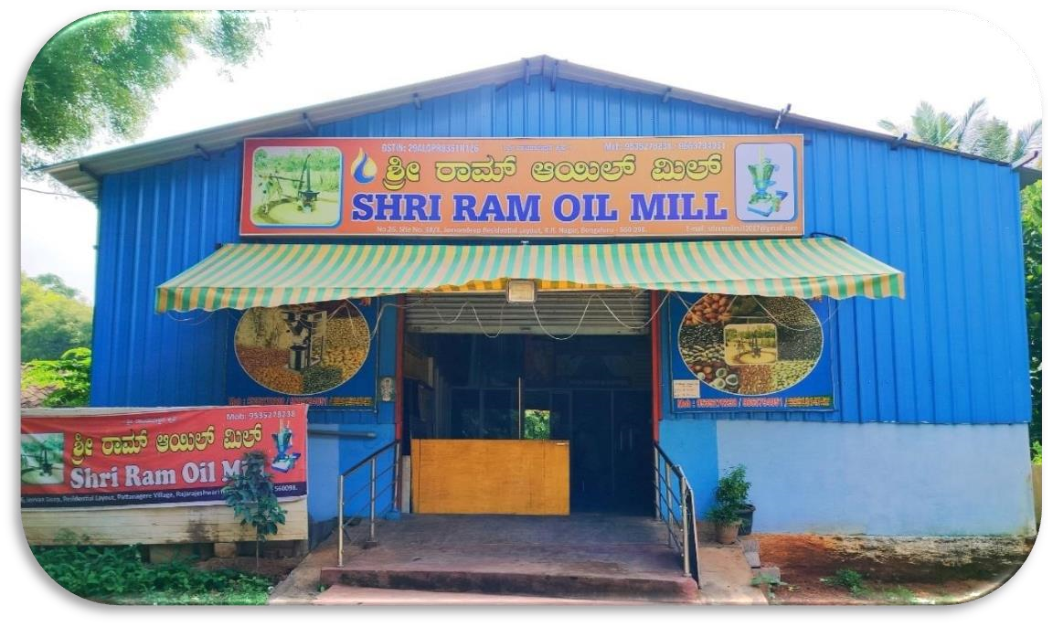

FIG NO: 2 Profile of the company

### 2.2 BRIEF INTRODUCTION OF THE FACTORY

Shriram Oil Mill is a Private factory incorporated on 10 March 2014. It is classified as Non govt factory and is registered at Registrar of Factories, Bangalore. It’s authorized with capital of Rs. 6,00,000 and its paid up capital is Rs. 5,00,000. It is involved in Business activities.

### 2.3 METHODOLOGY OF THE STUDY

The research is an exploratory in nature. Both primary and secondary sources of data have been used in the study.

* **Define Objectives and Scope:**

* + Clearly state the purpose of your study.
  + Define the scope of the factory you are studying, including its size, location, and type of production.

* **Literature Review:**

* + Research existing studies or literature related to the specific type of factory or industry you are studying.
  + Identify key concepts, theories, and best practices.

* **Data Collection:**

* + Choose appropriate data collection methods, such as observation, surveys, interviews, or document analysis.
  + Collect quantitative data (e.g., production output, energy consumption) and qualitative data (e.g., employee experiences, safety protocols).

* **Site Visit:**

* + If possible, visit the factory to observe its operations firsthand.
  + Take notes, photographs, and gather relevant documents during the visit.

* **Data Analysis:** 
  + Organize and clean the collected data. o Use statistical tools and software for quantitative analysis. o Employ content analysis or thematic coding for qualitative data. o Identify patterns, trends, and outliers.

* **Performance Evaluation:** 
  + Assess the factory's performance based on predetermined criteria, which may include efficiency, quality, safety, and sustainability.
  + Compare performance metrics to industry standards or benchmarks.

* **Identify Challenges and Opportunities:** 
  + Highlight issues and challenges the factory faces. o Identify opportunities for improvement or optimization.

* **Recommendations:**  o Develop recommendations based on your analysis and findings.
  + Provide actionable suggestions for enhancing factory operations, productivity, or sustainability.

* **Report Writing:** 
  + Prepare a comprehensive report that includes an introduction, methodology, findings, analysis, recommendations, and conclusion.
  + Use visual aids like charts and graphs to support your findings.

* **Presentation:**  o Present your findings to relevant stakeholders, such as factory management or interested parties. o Be prepared to answer questions and provide further insights.

* **Feedback and Revision:**  o Incorporate feedback from stakeholders and revise your report if necessary.
* **Implementation and Monitoring**:

* + If your recommendations are accepted, monitor the implementation of changes and their impact over time. o Adjust strategies as needed. \

**ABOUT:**

Sri Ram Oil Mill in Rajarajeshwari Nagar, Bangalore is known to satisfactorily cater to the demands of its customer base. The business came into existence in 2014 and has, since then, been a known name in its field. It stands located at No. 402, 4th Cross, BHEL Layout, Opposite to BHEL Park., Pattanagere, Rajarajeshwari Nagar, Bengaluru-560098 Karnataka. Opposite to BHEL Park is a prominent landmark in the area and this establishment is in close proximity to the same. The business strives to make for a positive experience through its offerings. The accepted modes of payment such as Cash, Debit Cards, Credit Card make every business transaction easy and seamless, contributing to making the entire process even more effective.

Customer centricity is at the core of Sri Ram Oil Mill in Rajarajeshwari Nagar, Bangalore, Karnataka and it is this belief that has led the business to build long-term relationships. Ensuring a positive customer experience, making available goods and/or services that are of topnotch quality is given prime importance. It is one of the players in Castor Oil, Groundnut Oil, Edible Oil, Organic Coconut Oil, Organic Mustard Oil to name a few.

India’s leading B2B market place, JD Mart ensures engaging in business activities is a seamless process for small and medium enterprises as well as large businesses. In a wake to enable these businesses to reach their audience, this portal lets them showcase their offerings in terms of the products and/or services through a digital catalogue. This business has a wide range of product offerings and the product/catalogue list includes:

**Edible Oil Wholesalers**

* Edible Oil Manufacturers
* Coconut Oil Manufacturers
* Ghee Manufacturers
* Sunflower Oil Manufacturers
* Groundnut Oil Manufacturers
* Safflower Oil Wholesalers
* Castor Oil Wholesalers
* Organic Flaxseed Oil Manufacturers
* Flaxseed Oil Manufacturers
* Plant Oil Wholesalers
* Filtered Groundnut Oil Manufacturers
* Organic Safflower Oil Wholesalers
* Pure Ghee Wholesalers
* Niger Seed Oil Manufacturers
* Plant Oil Manufacturers
* Organic Coconut Oil Manufacturers ➢ Groundnut Oil Wholesalers.

### WHY SHRIRAM OIL MILL

Within a limited period of time, they have been able to carve a niche for their selves by fulfilling the exact requirements of the customers in a cost-effective manner. Also, to carry out all actions with ease, they have divided this facility into a number of departments.

They have gained an edge over other competitor firms because of many important reasons:

Bulk production capacity

Quality-tested products

Affordable product range

Ethical business practices

High mechanical strength

Dimensional accuracy

High durability.

### 2.4 VISION OF THE FACTORY

Vision of Shriram Oil Mill is to continue the heritage of the Factory and be a best manufacturer of top quality products. To be the best supplier to the customers. The main moto of this factory entrepreneur is to provide a organic related products in this non healthy generation.

### 2.5 MISSION OF THE FACTORY

Mission of Shriram Oil Mill is to produce and continually develop quality products at a competitive price while fostering a climate where environmental technologies can thrive. With natural aspirated cold press oil for the customers where it is 100% pure and organic.

### 2.6 MEMBERS OF THE FACTORY

LOHITH BR- CEO

LATHA G-DIRECTOR

SHASHI P-MANAGER

### 2.7 QUALITY ASSURANCE BY THE FACTORY

Quality is the most important aspect of their factory and in order to achieve that they always ensure to enhance their quality levels of product and services. They aim to achieve and maintain business leadership by continuously striving for excellence in the entire spectrum of their business activities. They have adopted a quality control system, where in each product is stringently monitored for eliminating any kind of flaws. Their team of quality inspectors meticulously checks their products on the basis of quality, durability, resistance to corrosion and efficiency. Their prime aim is to provide their customers with utmost level of satisfaction at economical prices.

### 2.8 TEAM OF THE FACTORY

They have a team of experienced and result oriented personnel. Their team play important role in understanding the customer need and provide them with the high-end machine. All their professionals work in a cordial and synchronized manner to maintain a friendly and harmonious environment within the premises. Due to their dedication they are able to achieve a respectable position in the market. The team members follow ethical business practice and strive to provide the customers with quality products as per their needs. Their team is always open to the suggestions and feedback given by their clients and thereupon works on them to meet their requirement.

### 2.9 INFRASTRUCTURE OF THE FACTORY

They have a very sophisticated state-of-art infrastructure. Their company is backed by cutting-edge infrastructural facilities for proper handling of their huge stocks. They have a very well organized manufacturing unit, with latest machines and technology. Their manufacturing units are very instrumental in their success. They have a huge warehouse spread over a large area for proper stocking of their machines and equipment. Due to this they are able to meet the timely demands of their customers. They operate in a very organized and professional way

### 2.10 PRODUCTS / SERVICES BY THE FACTORY

Shriram Oil Mill provides a very good products and services to their customers. Then ensure to give a high quality products. They produce many types of products required equipment's like oil crushing machines, oil filters, storing machine, seeds grinding machines, packing machines etc.

### OIL CRUSHING MACHINE

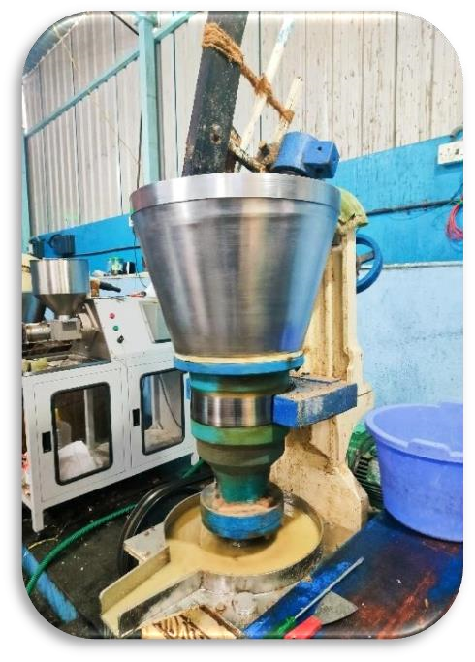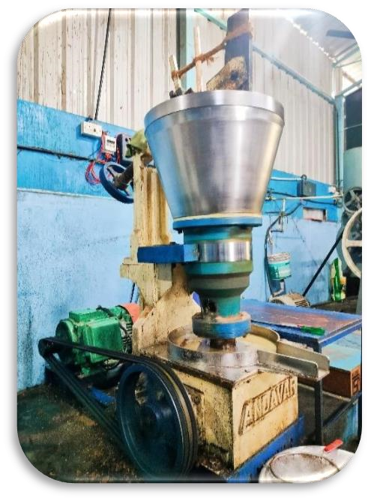

FIG NO: 3 Oil crushing machine 1FIG NO: 4 Oil crushing machine 2

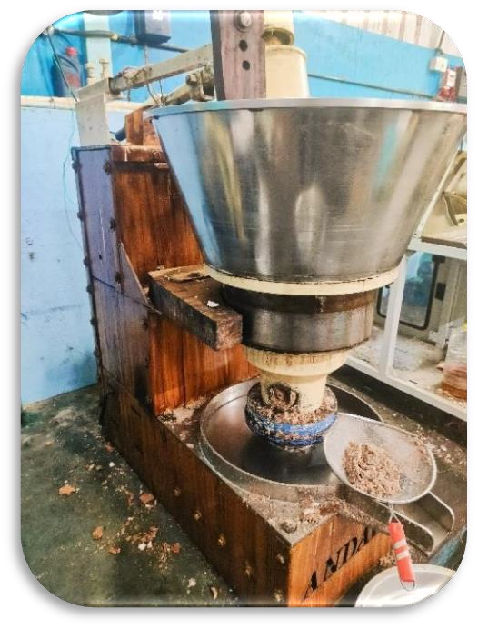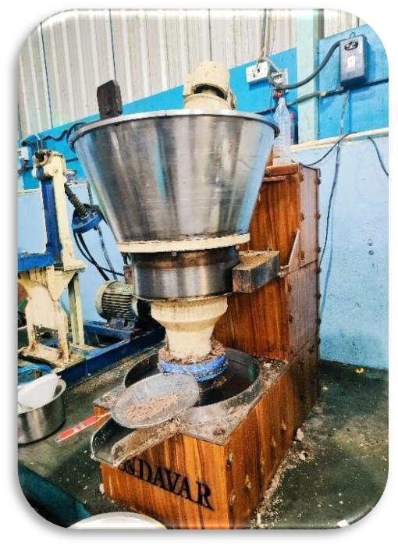

FIG NO: 5 Coconut crushing machine-1 FIG NO: 6 Coconut crushing machine-2

### OIL FILTER MACHINE

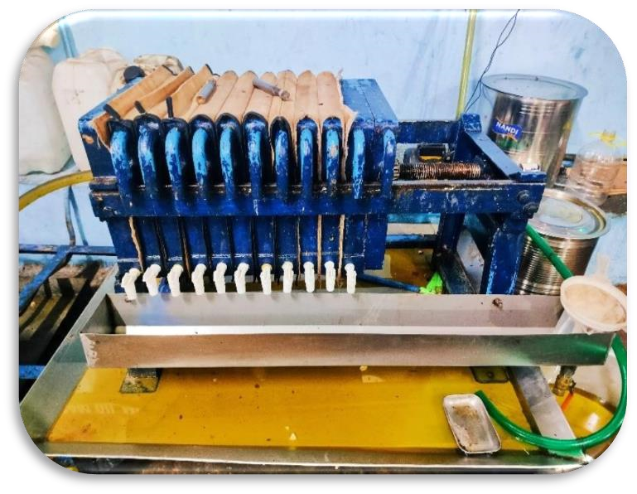

FIG NO: 7 Oil filter machine-1

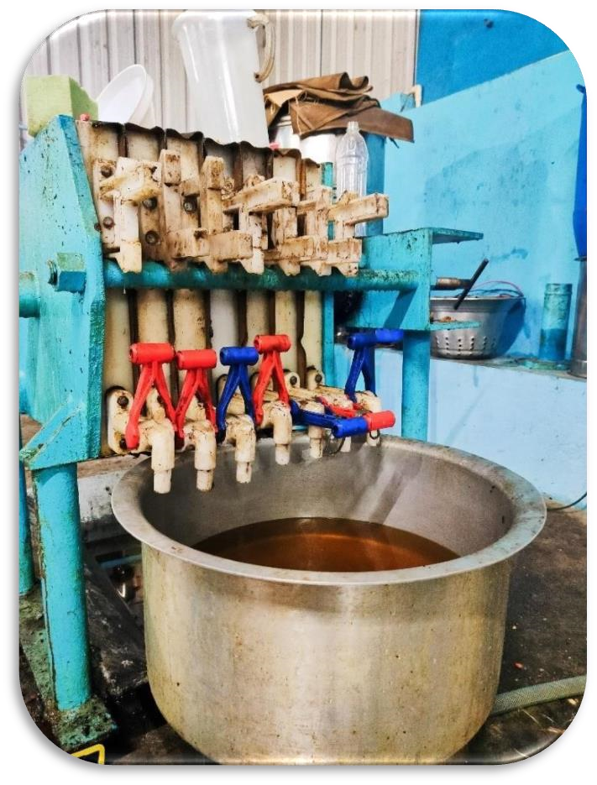

FIG NO: 8 Oil filter machine-2

### OIL STORING MACHINE

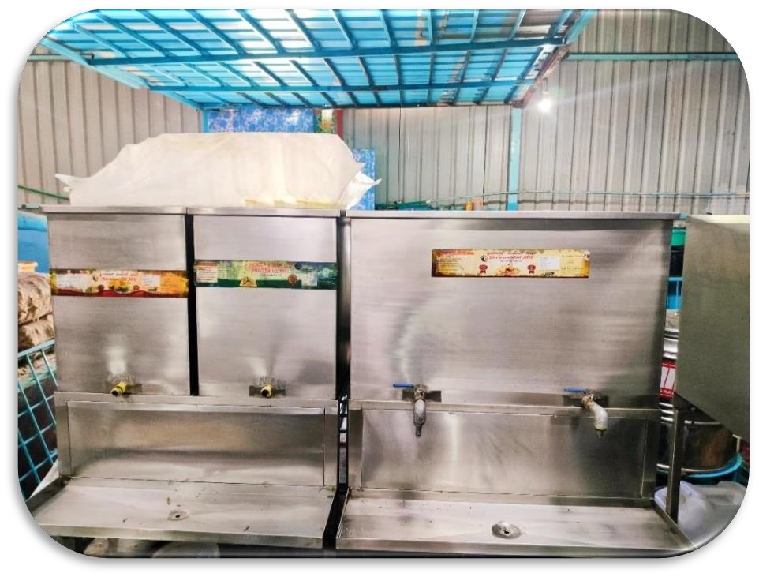

FIG NO: 9 Oil storing container

### CUSTOMER INTERACTION

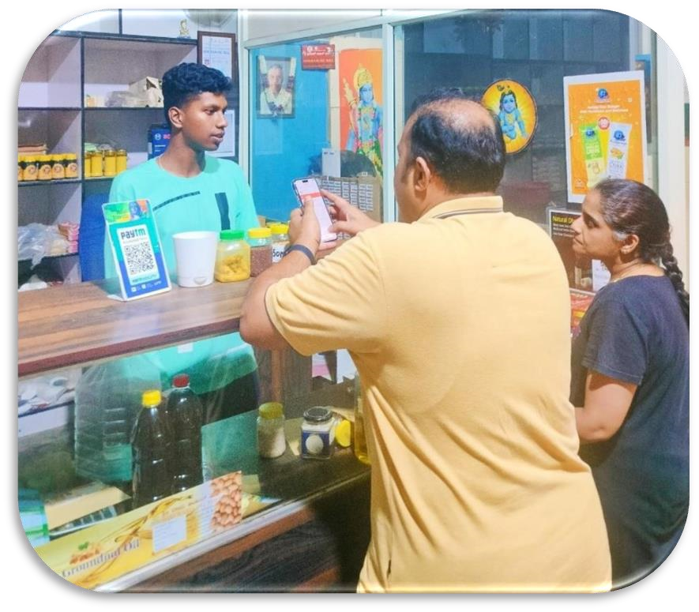

FIG NO: 10 Interaction with customer

### SEEDS CRUSHINGMACHINE

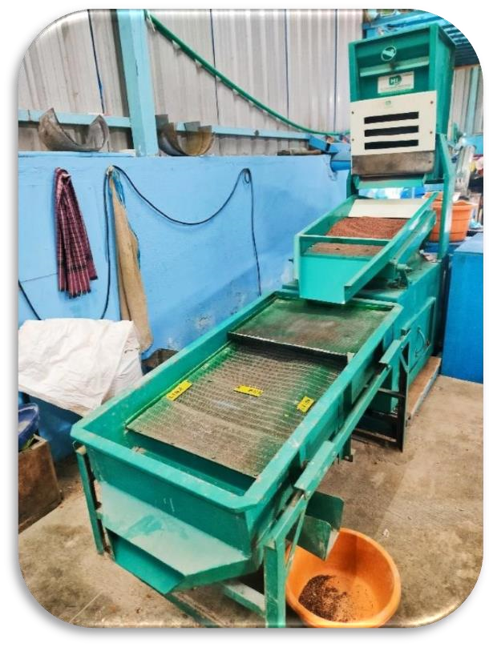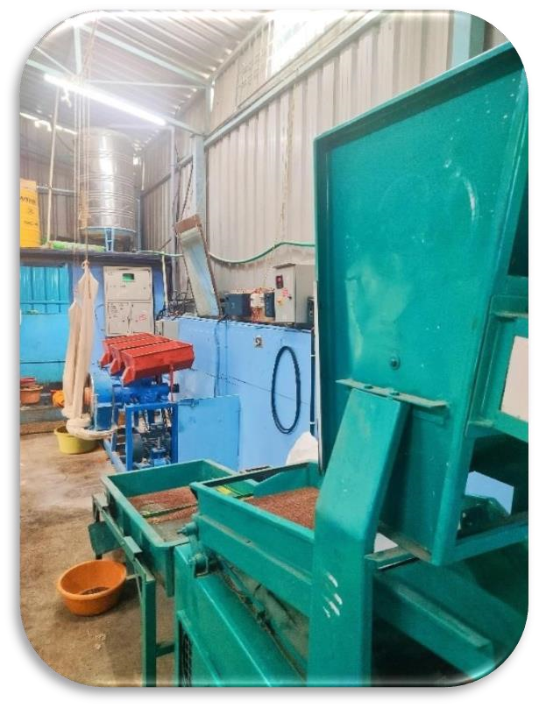

FIG NO: 11 Seed cleaning machine-1 FIG NO: 12 Seed cleaning machine-2

### GRINDING MACHINE

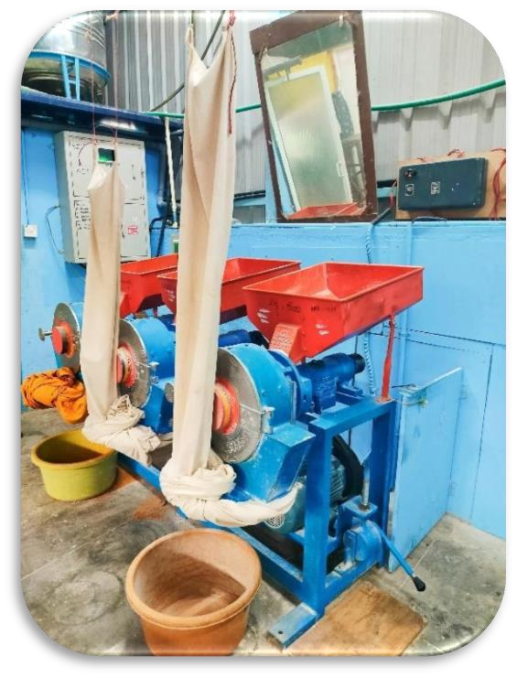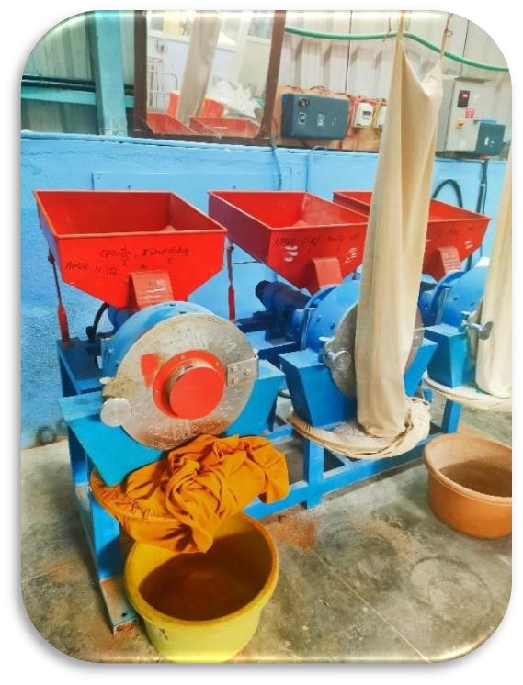

FIG NO: 13 Grinding machine-1 FIG NO: 14 Grinding machine-2

**PRODUCTS**

### GROUNDNUT OIL

* Source of unsaturated fats
* Maintains heart health
* Contains antioxidants
* Skin care
* Slow cognative disorders
* Nutrient rich
* Cooking versatility

FIG NO: 15

### COCONUT OIL

* Encourage fat burning
* Help reduce seizures
* Boost skin health
* Protect your hair
* Improve oral health
* A good antioxidant source
* Help reduce alzheimer’s diesease FIG NO: 16

### SAFFLOWER OIL

* A healthful source of fatty acid
* Improves blood sugar level
* Fights inflammation
* Smooths dry skin
* Safe for cooking at high temperature
* Good for weight loss
* Lowers cholesterol
* Boost heart health

FIG NO: 17

### MUSTARD OIL

* It improves circulation
* Improves appetite
* Prevent fungal infections
* Good for health
* It improves sweting
* It is a toner

FIG NO: 18

### NIGER OIL

* Good for heart health
* Improves skin care
* Nutralize PH level
* Sleep aid
* Speeds up healing
* Good pain reliever
* Reduces inflammation

FIG NO: 19

 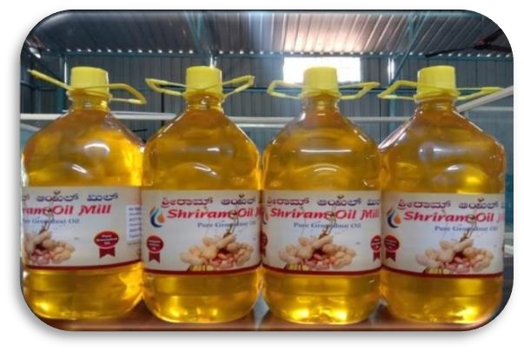

FIG NO: 20 Packaged oil bottles FIG NO: 21 Packaged oil bottles

## CHAPTER – 3 – WORKING EXPERIENCE IN THE MARKETING

### 3.1 WORK UNDERTAKEN IN THE FACTORY

As I joined the Shriram Oil Mill as an intern and worked in customer relationship department, my duty and responsibility was to study about the products and explain the studied information to the customers by selling the products and by building a good relationship, Providing the relevant information that the leads require. Being a seller should have a positive attitude and excellent communication etiquette. Be calm and professional under pressure and always treat customer needs with respect. Customer Relationship requires patience, persuasiveness, and persistence. It's also important to have excellent communication skills alongside the ability to perform in a factory setting. Most important, selling the products is all about building repeat business through good customer relations.

Started contacting them and had to explain about the products and services provided by the factoring and also provided information as per the leads requires.

As I was responsible to contact each customer and approach them to buy the products of the factory, follow up on enquiry and data. Understand the customer requirement and guide them to the right product and services they required. Had to tell the customers about the website of the factory so they could know about the price and clear information about the product.

I did my internship in Shriram Oil Mill as marketer was a good experience where I could express my ideas and learn new things like sales strategy, communicating to the customers and selling their products. over all it was good experience in the factory.

### LEARNING OBJECTIVE

➢ **Understanding Customer Needs and Behaviors**

* Customer Segmentation: Learn how to segment customers based on demographic, psychographic, and behavioral data.
* Customer Journey Mapping: Understand the stages of the customer journey and how to optimize each touchpoint.
* Data Analysis: Gain skills in using data analytics to uncover insights about customer behavior and preferences.

* + **Effective Communication**

* Personalization: Develop techniques for personalizing communication based on customer data to enhance engagement.
* Multichannel Communication: Learn how to effectively communicate with customers across various platforms (email, social media, phone, in-person).
* Conflict Resolution: Master strategies for handling customer complaints and conflicts in a constructive manner.

* + **Customer Retention Strategies**

* Loyalty Programs: Understand how to design and implement loyalty programs that reward repeat customers.
* Customer Satisfaction: Learn methods to measure and improve customer satisfaction through surveys and feedback.
* Proactive Engagement: Develop strategies to proactively engage customers to anticipate their needs and reduce churn.

* + **CRM Tools and Technologies**

* CRM Software Proficiency: Gain hands-on experience with popular CRM platforms (e.g., Salesforce, HubSpot).
* Automation and AI: Understand how to use automation and artificial intelligence in CRM to streamline processes and enhance customer interactions.
* Data Integration: Learn how to integrate CRM systems with other business tools (e.g., marketing automation, ERP systems).

* + **Sales and Service Integration**

* Sales Process Optimization: Learn how to align CRM strategies with sales processes to improve conversion rates and sales efficiency.
* Service Excellence: Understand how to leverage CRM to provide exceptional customer service and support.
* Cross-Department Collaboration: Develop skills to foster collaboration between sales, marketing, and service teams through shared CRM data.

* + **Customer Feedback and Improvement**

* Feedback Collection: Understand various methods for collecting customer feedback (e.g., surveys, focus groups, online reviews).
* Feedback Analysis: Learn techniques for analyzing feedback to identify trends and areas for improvement.
* Continuous Improvement: Develop processes for using feedback to drive continuous improvement in products, services, and customer interactions.

* + **Strategic Planning and Implementation**

* CRM Strategy Development: Gain skills in developing a comprehensive CRM strategy that aligns with business goals.
* Change Management: Understand how to manage organizational change to ensure successful CRM implementation.
* Customer-Centric Culture: Learn how to foster a customer-centric culture within the organization.

* + **Measuring CRM Effectiveness**

* Key Performance Indicators (KPIs): Learn which KPIs to track to measure the success of CRM initiatives (e.g., customer lifetime value, retention rate).
* Reporting and Dashboards: Gain proficiency in creating and interpreting CRM reports and dashboards to monitor performance.
* ROI Analysis: Understand how to calculate the return on investment for CRM initiatives and justify expenditures.

### 3.2 SALES DEPARTMENT



FIG NO: 22 Sales department

**INTRODUCTION:**

The sales department in a factory is responsible for managing the sale of the factory's products. This department typically includes sales representatives or teams who interact with customers, negotiate contracts, process orders, and ensure the timely delivery of goods.

They play a crucial role in generating revenue for the factory by selling its products to distributors, retailers, or directly to consumers, depending on the business model. Additionally, the sales department may collaborate with marketing and production teams to optimize sales strategies and meet revenue targets.

At Shree ram oil mill, sales isn't just about closing deals—it's about understanding our customers' needs, solving their challenges, and delivering value that goes beyond the transaction. With a customer-centric approach and a focus on innovation, we strive to be the trusted advisors our clients rely on to achieve their business goals.

Led by seasoned experts with years of industry experience, our Sales Department operates with integrity, transparency, and a relentless pursuit of excellence. We embrace collaboration, creativity, and continuous improvement, leveraging the latest tools and techniques to stay ahead of the curve and deliver results that make a difference.

Whether you're a seasoned professional or a rising star, the Sales Department at Shree ram oil mill offers endless opportunities for growth, development, and success. Join us on the journey to greatness as we redefine what it means to be a sales leader in today's dynamic marketplace.

.

### FUNCTIONS

* **Prospecting**: Identifying potential customers and leads who might be interested in the factory's products.

* **Lead Generation:** Generating leads through various methods like marketing campaigns, cold calling, networking, or referrals.

* **Customer Relationship Management (CRM):** Maintaining and nurturing relationships with existing customers to encourage repeat business and loyalty.

* **Sales Presentations:** Preparing and delivering presentations to showcase the factory's products and their benefits to potential customers.

* **Sales Negotiation:** Negotiating terms, pricing, and contracts with customers to secure deals and meet their needs.

* **Order Processing:** Managing the paperwork and systems necessary to process customer orders accurately and efficiently.

* **Quoting and Pricing:** Providing customers with quotes and pricing information based on their specific requirements.

* **Market Research:** Continuously monitoring market trends, competitor activities, and customer feedback to adapt sales strategies.

* **Sales Reporting:** Generating reports on sales activities, performance metrics, and forecasts to track progress and make data-driven decisions.

* **Customer Support:** Addressing customer inquiries, concerns, and providing post-sales support to ensure customer satisfaction.

* **Sales Training:** Training and developing sales teams to improve their product knowledge, communication skills, and sales techniques.

* **Sales Forecasting:** Predicting future sales trends and setting sales targets and goals for the department.

* **Collaboration:** Working closely with marketing, production, and other departments to align strategies and ensure products meet market demand.

* **Customer Acquisition:** The sales team is responsible for identifying potential customers, understanding their needs, and converting leads into actual clients through effective communication and persuasion.

* **Customer Retention:** Building long-term relationships with customers by ensuring satisfaction, addressing concerns, and providing ongoing support. This involves regular follow-ups and personalized service.

* **Customer Feedback and Insights:** Collecting feedback from customers about products and services to understand their experiences and expectations. This information is vital for improving offerings and tailoring future interactions.

### 3.3 TYPES OF SALES

* **Direct Sales:** This involves selling products directly from the factory to customers. It can include both business-to-business (B2B) sales, where products are sold to other businesses, and business-toconsumer (B2C) sales, where products are sold to individual consumers.

* **Wholesale Sales:** Factories often sell their products in bulk to wholesalers who then distribute the products to retailers or other businesses. Wholesale sales typically involve larger quantities at lower prices per unit.

* **Retail Sales:** Some factories have their own retail outlets where they sell their products directly to consumers. This allows the factory to capture a larger share of the retail price and have more control over branding and customer experience.

* **Online Sales:** With the rise of e-commerce, many factories have established online sales channels to reach a broader customer base. This can include selling through their own website or through thirdparty online marketplaces.

* **Export Sales:** Factories may export their products to international markets. Export sales involve compliance with international trade regulations and may require partnerships with export agencies or distributors in target countries.

* **OEM Sales:** Original Equipment Manufacturer (OEM) sales involve selling products to other companies that use them as components in their own products. For example, a factory that produces automobile parts may sell them to car manufacturers.

* **Aftermarket Sales:** Aftermarket sales involve selling replacement parts or accessories for products that the factory originally manufactured. This can be a lucrative source of revenue for factories.

### 3.4 MANUFACTURING DEPARTMENT

The manufacturing department plays a critical role in transforming raw materials into finished products through various processes, ensuring quality and efficiency. This department is responsible for the planning, coordination, and control of manufacturing activities. It includes a range of functions such as production planning, scheduling, and maintenance of machinery. Key tasks involve overseeing the production line, managing workforce, and implementing quality control measures to maintain standards. Additionally, the manufacturing department collaborates closely with other departments like supply chain management, procurement, and research and development to optimize production processes, reduce costs, and meet delivery timelines. Emphasis on continuous improvement, lean manufacturing, and the adoption of new technologies are also pivotal to enhance productivity and competitiveness in the market.

### 3.5 KEY FUNCTIONS AND RESPONSIBILITY

* **Production Planning and Scheduling:** The manufacturing department begins with detailed production planning, which involves determining the sequence of operations, resource allocation, and timelines for manufacturing tasks. Scheduling ensures that every phase of production is completed on time, aligning with delivery commitments.

* **Resource Management:** Efficient management of materials, machinery, and human resources is essential. This includes procurement of raw materials, maintenance of inventory levels, and ensuring machinery is functional and well-maintained to avoid downtime.

* **Process Control and Quality Assurance:** Maintaining high-quality standards is a top priority. The department implements rigorous quality control processes, including regular inspections and testing at various stages of production. This ensures that defects are identified and rectified promptly, maintaining product integrity and customer satisfaction.

* **Workforce Management:** The manufacturing workforce, consisting of skilled operators, technicians, and supervisors, is managed to optimize productivity. This involves training, shift scheduling, performance monitoring, and ensuring a safe working environment compliant with health and safety regulations.

* **Collaboration and Coordination:** The manufacturing department works closely with other departments, such as:
* Supply Chain Management: For seamless flow of materials and components.
* Procurement: To ensure timely acquisition of quality raw materials.
* Research and Development (R&D): To implement new manufacturing technologies and processes that improve efficiency and product quality.
* Sales and Marketing: To align production schedules with market demands and customer orders.

* **Continuous Improvement and Lean Manufacturing:** Embracing continuous improvement methodologies like Kaizen and lean manufacturing principles is crucial. These practices focus on eliminatingwaste, reducing costs, and enhancing efficiency through streamlined operations and employee involvement.

* **Technology Integration:** The adoption of advanced manufacturing technologies, such as automation, robotics, and IoT (Internet of Things), plays a significant role in modern manufacturing. These technologies enhance precision, speed, and flexibility while providing valuable data for further process optimization.

* **Maintenance and Safety:** Regular maintenance schedules for machinery and equipment are vital to prevent breakdowns and ensure uninterrupted production. The department also emphasizes a strong safety culture to minimize workplace accidents and comply with occupational health and safety standards.

* **Environmental Compliance:** Sustainable manufacturing practices are increasingly important. The department strives to minimize environmental impact by reducing waste, recycling materials, and ensuring compliance with environmental regulations.

**REQUIRED FOR:**

* Production of goods
* Efficiency and cost control
* Quality control
* Scaling Productions
* Consistency
* Innovation and Improvement • Inventory Management • Job Creation.

### 3.6 Different Types of Manufacturing

* **Batch Manufacturing:** In this approach, products are made in batches, meaning a specific quantity of items is produced before switching to a different product or setup. It's suitable for custom or small-scale production.

* **Continuous Manufacturing:** Continuous manufacturing involves the continuous production of goods without interruptions. This is often used in industries like chemicals, oil refining, and food processing.

* **Mass Production:** Mass production focuses on producing large quantities of identical products efficiently. Assembly lines and automation are common in mass production.

* **Custom Manufacturing:** Custom manufacturing is highly flexible and tailored to individual customer requirements. Each product may be unique, and production processes are adjusted accordingly.

* **Lean Manufacturing:** Lean manufacturing aims to minimize waste in the production process, including excess inventory, overproduction, and inefficient processes. It focuses on efficiency and reducing costs.

* **Just-in-Time (JIT) Manufacturing:** JIT manufacturing seeks to minimize inventory by producing products only as they are needed. This reduces storage costs and waste.

* **Make-to-Order (MTO):** Products are only manufactured when an order is received. This reduces the need for inventory but may result in longer lead times.

* **Make-to-Stock (MTS):** Products are manufactured in anticipation of customer demand, allowing for quicker delivery but requiring more inventory.

* **Cellular Manufacturing:** It organizes manufacturing into cells, where a group of workers and machines handle a specific set of processes. This approach promotes efficiency and teamwork.

* **Flexible Manufacturing Systems (FMS):** FMS uses computer-controlled systems to automate and optimize production processes, allowing for quick changes in production tasks.

* **Additive Manufacturing (3D Printing):** This innovative process builds products layer by layer from digital designs, enabling complex geometries and rapid prototyping.

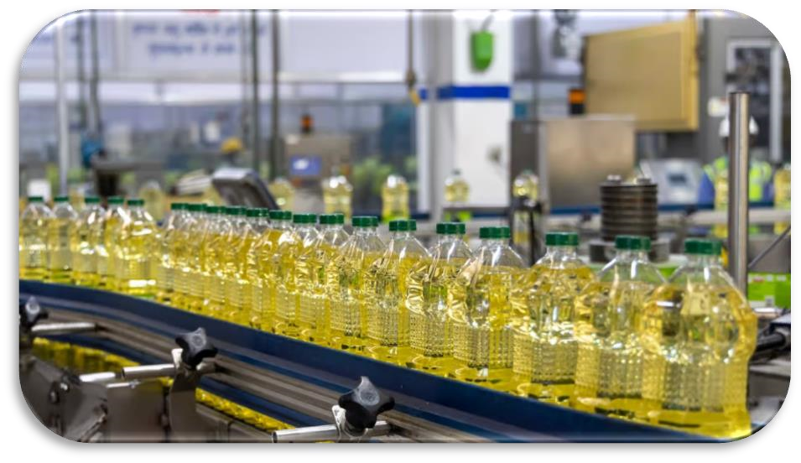

Fig No:23 Types of manufacturing

### 3.7 Selling Process

The selling process in customer relationship management (CRM) involves several key stages designed to build and maintain strong, long-lasting relationships with customers while driving sales. It begins with prospecting and lead generation, where potential customers are identified and approached through various marketing strategies. Next, needs assessment and qualification are conducted to understand the customer's specific requirements and determine if they are a good fit for the products or services offered. The sales team then presents a tailored solution, highlighting the benefits and addressing any concerns the customer might have. This is followed by negotiation and handling objections, where the salesperson works to resolve any remaining issues and agree on terms. Once an agreement is reached, the sale is closed, and the customer completes the purchase. Post-sale activities include follow-up communications to ensure customer satisfaction, addressing any issues, and providing support. This continuous engagement fosters loyalty and encourages repeat business, ultimately enhancing the customer lifetime value and strengthening the overall customer relationship.

### Steps in these process

* **Market Research:** The factory assesses market demand and identifies potential customers for its products.

* **Product Development:** The factory designs and manufactures products that meet customer needs and market trends.

* **Pricing Strategy:** Pricing is determined based on production costs, market competition, and desired profit margins.

* **Sales Team:** A sales team may be established to promote and sell the factory's products. This team could include sales representatives, account managers, or distributors.

* **Marketing and Promotion:** Marketing efforts are crucial to create awareness about the factory's products. This may involve advertising, online marketing, trade shows, or other promotional activities.

* **Sales Process:** The factory's sales team engages with potential customers, presents the products, and negotiates terms and conditions of sale.

* **Order Processing:** Once a sale is made, orders are processed, and production schedules are adjusted to meet customer demand.

* **Delivery and Logistics:** Products are prepared for shipment, and logistics arrangements are made to ensure timely delivery to customers.

* **Customer Support:** Providing excellent customer support ensures customer satisfaction and can lead to repeat business.

* **Feedback and Improvement:** Feedback from customers is valuable for product improvement and enhancing the selling process.



Fig No:24 Selling process

### 3.8 Advantages of Sales

* **Direct Access to Production:** Sales teams in a factory have immediate access to the production process, allowing them to provide accurate information about product availability, lead times, and customization options to customers.

* **Efficient Communication:** Sales staff can quickly relay customer feedback and special requests to the production team, facilitating faster response times and customization of orders.

* **Quality Control:** Being on-site allows salespeople to closely monitor the quality of products and address any issues promptly, ensuring customer satisfaction and reducing the likelihood of returns or complaints.

* **Cost Savings:** Factory-based sales can often eliminate the need for intermediaries, reducing distribution costs and potentially leading to more competitive pricing for customers.

* **Product Knowledge:** Sales personnel in a factory environment tend to have an in-depth understanding of the products they sell, enabling them to provide expert advice and solutions to customers.

* **Customization Opportunities:** Factory sales teams can work closely with customers to tailor products to their specific needs, fostering long-term relationships and loyalty.

* **Streamlined Operations:** Factory-based sales can streamline order processing, minimize shipping times, and improve overall supply chain efficiency.

* **Feedback Loop:** Sales teams can provide valuable feedback to the production team about market demand and trends, helping the factory adapt and innovate its offerings.

* **Quick Problem Resolution:** Any issues that arise, such as order discrepancies or delivery delays, can be resolved swiftly since sales and production teams are co-located.

* **Stronger Customer Relationships**: The ability to offer factory tours and direct engagement with the production process can enhance trust and build stronger relationships with customers.

* **Enhanced Customer Loyalty:** Building strong relationships through personalized sales interactions increases customer loyalty. Satisfied customers are more likely to return and make repeat purchases.

* **Improved Customer Retention:** Effective CRM strategies help retain customers by addressing their needs and concerns promptly, reducing churn rates and fostering long-term relationships.

* **Increased Sales and Revenue:** By understanding customer preferences and buying behavior, sales teams can tailor their approaches, leading to higher conversion rates and increased sales volumes.

* **Better Customer Insights:** CRM systems provide valuable data on customer interactions, preferences, and purchasing history. This information helps sales teams to anticipate needs and offer relevant products or services.

* **Personalized Customer Experience:** Personalized interactions based on CRM data make customers feel valued and understood, enhancing their overall experience and satisfaction.

* **Efficient Sales Processes:** CRM tools streamline sales processes by automating tasks, tracking interactions, and managing leads, which allows sales teams to focus more on building relationships and closing deals.

* **Effective Targeting and Segmentation:** CRM enables precise customer segmentation, allowing sales teams to target specific groups with tailored marketing and sales strategies, improving campaign effectiveness.

* **Enhanced Communication:** Consistent and clear communication with customers, facilitated by CRM, ensures that customers are well-informed and engaged throughout the sales process.

* **Increased Customer Lifetime Value:** Strong customer relationships lead to higher customer lifetime value (CLV) as customers continue to purchase over time and potentially increase their spend.

### 3.9 Disadvantages of sales

* **Pressure and Aggressiveness:** Sales techniques that involve high pressure, such as persistent calls, pushy emails, or hard-sell tactics during meetings, can make customers feel uncomfortable and harassed. This can lead to a negative perception of the company and reluctance to engage in future transactions.

**Example:** A customer who is constantly followed up with aggressive sales calls might choose a competitor simply to avoid the pressure, even if the original company's product was superior.

* **Lack of Personalization:** When sales strategies focus on numbers rather than individual customer needs, interactions can become impersonal. Customers may feel like just another number rather than a valued client, leading to dissatisfaction.

**Example:** If a software company pushes the same standard package to all clients without considering their specific business needs, customers may find the product does not meet their requirements, leading to churn.

* **Short-term Focus:** Sales targets often emphasize immediate revenue, which can overshadow the importance of building long-term relationships. This short-term approach can result in neglecting customer loyalty and lifetime value.

**Example:** A car dealership that prioritizes making a sale over providing excellent service may lose out on repeat business and referrals, which are crucial for sustained growth.

* **Misaligned Incentives:**  Salespeople are often incentivized to meet quotas or earn commissions, which can sometimes conflict with providing the best solution for the customer. This misalignment can harm trust and satisfaction.

**Example:** A salesperson might push for a more expensive model or additional features that the customer doesn't need or can't afford, leading to buyer's remorse.

* **Overpromising and Under-delivering:** To close deals, salespeople might exaggerate the capabilities of a product or service. When the product fails to meet these inflated expectations, it can result in significant customer dissatisfaction and complaints.

**Example**: A customer buys an enterprise software solution based on promises of easy integration and immediate productivity gains, but faces numerous technical issues and a steep learning curve.

* **Neglecting Post-Sale Support**: After the sale is made, if the customer does not receive adequate support and follow-up, they may feel abandoned. Good post-sale service is crucial for customer satisfaction and retention.

**Example:** A customer purchases a home appliance but struggles with setup and usage, and the lack of responsive customer support leads to frustration and a negative review.

* **Ethical Concerns:** Aggressive sales tactics can sometimes cross ethical boundaries, such as making false claims or exploiting a customer's lack of knowledge. Such practices can lead to legal issues and damage the company's reputation.

**Example:** A financial advisor selling investment products that are not in the best interest of the client but generate higher commissions can lead to significant financial loss and loss of trust.

* **Impersonal Communication:** Detailed Insight: Over-reliance on scripts, automated emails, and standardized processes can make customer interactions feel robotic and uncaring. Personalized engagement is often more effective in building strong relationships.

**Example:** An online retailer that uses automated responses for all customer inquiries may come across as indifferent to specific customer problems, leading to dissatisfaction.

* **Complexity and Confusion:** Sales processes that are overly complex or involve too much jargon can confuse customers, making them less likely to complete a purchase or feel satisfied with their decision.

**Example:** A customer trying to understand a convoluted mobile phone plan may become frustrated and look for simpler options elsewhere.

* **Inconsistent Messaging:** Inconsistent information from different sales representatives or channels can confuse customers and reduce trust in the company.

**Example:** One representative promises a discount that another says is not available, leading to customer frustration and perceived dishonesty.

* **Ignoring Customer Feedback**: Detailed Insight: Sales teams that do not actively seek or respond to customer feedback miss out on valuable insights that can improve products and services.

### 3.10 Problem on sales

* **Miscommunication and Misunderstanding:** Sales representatives may not fully understand customer needs or miscommunicate the benefits and features of a product, leading to dissatisfaction.

**Example:** A salesperson selling a complex software solution fails to grasp the specific requirements of the customer’s business. As a result, the customer ends up with a product that doesn’t meet their needs, leading to frustration and potential loss of business.

* **Overemphasis on Closing the Sale:** Focusing too much on closing the deal can make customers feel rushed and undervalued, potentially driving them away.

**Example:** In a retail setting, a salesperson pushes a customer to make a purchase decision quickly without allowing them to explore all their options. This pressure can make the customer uncomfortable, resulting in them leaving without making a purchase.

* **Inconsistent Customer Experience:** Different sales representatives providing inconsistent information or varying levels of service can confuse and frustrate customers.

**Example:** A customer who receives detailed, helpful information from one salesperson but gets vague, unhelpful responses from another may feel uncertain about the reliability and consistency of the company.

* **Lack of Customer Empowerment**: Not involving customers in the decision-making process or failing to give them enough information to make an informed choice can lead to resentment and a feeling of disempowerment.

**Example:** A car dealership that pushes specific models without listening to the customer’s preferences and budget constraints can make the customer feel unheard and pressured.

* **Misaligned Incentives:** Sales teams motivated by targets and commissions might prioritize their goals over customer needs, leading to recommendations that are not in the best interest of the customer.

**Example**: A financial advisor suggesting high-commission investment products that don’t align with the customer’s risk tolerance or financial goals can lead to financial loss and eroded trust.

* **Insufficient Training:** Sales representatives without proper training may lack the product knowledge or customer service skills necessary to build strong relationships.

**Example:** A tech retail store employee who doesn’t fully understand the specifications of the latest gadgets may give incorrect advice, leading to customer dissatisfaction and returns.

* **Ignoring Customer Feedback:** Not actively seeking or responding to customer feedback can prevent businesses from addressing issues and improving their offerings.

**Example:** A subscription service that receives numerous complaints about billing errors but fails to correct them risks losing subscribers to competitors who handle feedback better.

* **High Turnover in Sales Staff:** Frequent changes in sales personnel can disrupt continuity and weaken customer relationships.

**Example:** A customer accustomed to dealing with a specific account manager who suddenly leaves the company may feel abandoned and less valued, affecting their loyalty to the business.

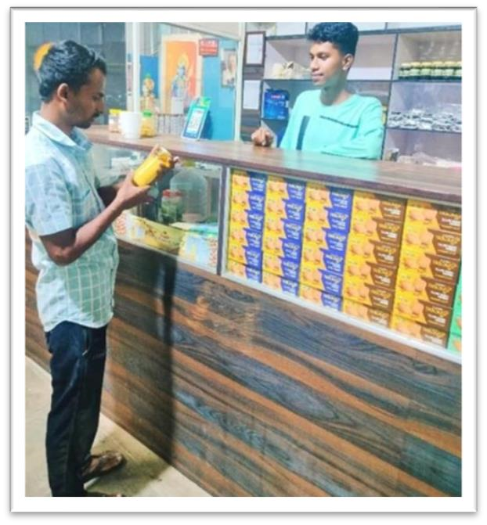

FIG NO: 25 Doing sales

## CHAPTER – 4 – SWOT ANALYSIS

### 4.1 SWOT ANALYSIS OF THE COMPANY

The term SWOT is the abbreviated form of Strength, Weakness, Opportunity and Threat. In SWOT analysis Strength and Weakness are determined by internal factor, while Opportunity and Threat are determined by the external factors.

Conducting a SWOT analysis of a company provides a comprehensive view of its internal and external environments, highlighting its strengths, weaknesses, opportunities, and threats. Strengths are the internal attributes that give the company a competitive edge, such as a strong brand reputation, a loyal customer base, advanced technology, and skilled workforce. Weaknesses, on the other hand, are internal limitations that hinder performance, including factors like high operating costs, outdated technology, or limited market reach.

Opportunities are external factors that the company can capitalize on to grow and improve its market position. These might include emerging markets, technological advancements, or shifts in consumer preferences that favor the company’s products or services. Threats are external challenges that could negatively impact the company, such as economic downturns, increased competition, regulatory changes, or supply chain disruptions.

By analyzing these four dimensions, a company can strategically plan to leverage its strengths, address its weaknesses, seize opportunities, and mitigate threats, thereby positioning itself for sustained success and growth in the marketplace.



FIG NO: 26 SWOT analysis

**S- Strength** Strengths can be both personal and business strengths, depending on the situation you’re analysing. These are things that are going well currently and that give your client an advantage over their competition. They include things like the client’s Unique Selling Proposition, the value they add to the marketplace, their good reputation among customers, and so on. They also include personal strengths, natural abilities, and skills the client now possesses.

### W- Weaknesses

Weaknesses are areas in which your client needs improvement. These may be situations where their business is struggling or obstacles that are holding them back from achieving their goals. They might be skills that are lacking or things the client wants to change about their current situation. These areas put the client at a disadvantage to their competition.

### O- Opportunities

Opportunities are things the client can take advantage of. They could be new business opportunities, new products, resources, potential business ventures, skills to learn, markets to tap into, or unfilled customer needs that they can address. Opportunities are external factors that can help your client gain an advantage over the competition.

### S- Threats

Threats are external challenges or obstacles that your client is facing. These could be financial problems, problems in the marketplace, the emergence of new competition, changing regulations, or threats to personal stability. These external obstacles put clients at a disadvantage against their competition.

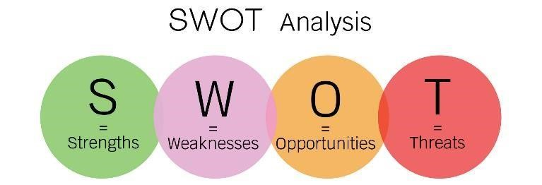

FIG NO: 27 SWOT analysis

### WORKING AREA

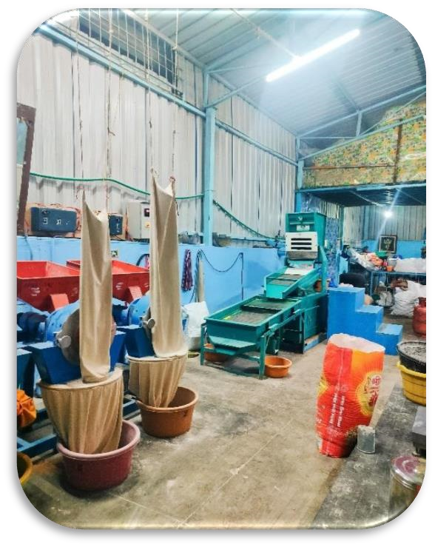

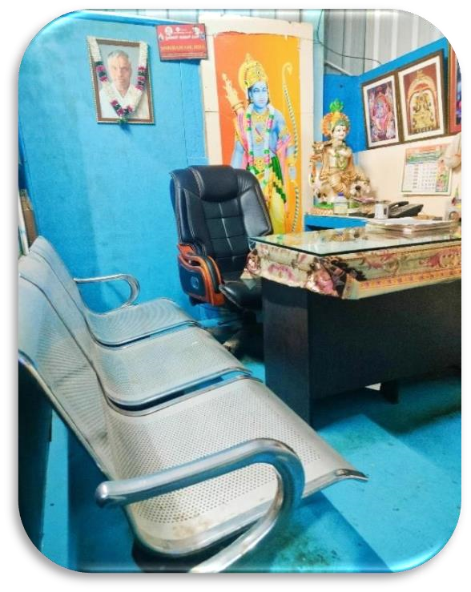

Fig no 28 Working office Fig no 29 Flour crushing area

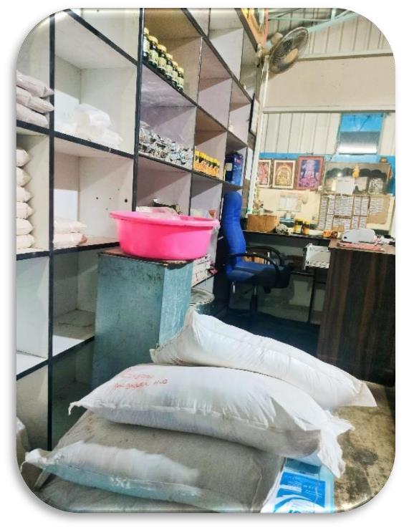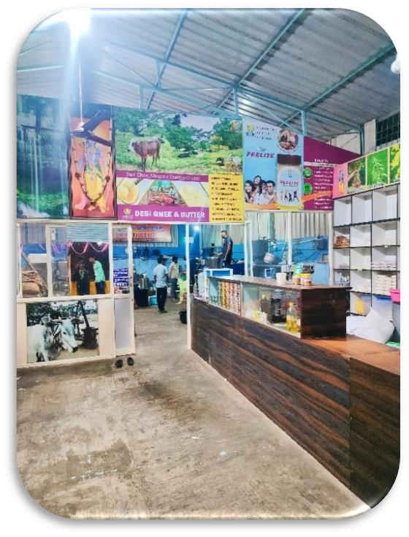

Fig no 30 Storage area Fig no 31 Customer purchase area

### 4.2 WORK EXPERIENCE IN THE FACTORY

The internship programe should be carried out by the students of final semester of BBA, as prescribed by Bangalore city university. Each student should complete the internship in any kind industry. I joined Shriram Oil Mill as an Intern and worked for 18 days. On the first day in factory, I met Mr. Lohitha B R [CEO and Head of Marketing].

Informed them about to work as intern in their factory and gave the letter head (permission letter) signed by the principal, and they hired me as intern to work in their company.

As I joined for Shriram Oil Mill on Sept 28 and worked till Oct 15 and completed my internship in the field of customer relationship in sales department, my duty and responsibility was to study about the products and explain the studied information to the customers by selling the product.

Providing the relevant information that the leads require. Being a customer relationship should have a positive attitude and excellent marketing etiquette. Be calm and professional under pressure and always treat customers/leads with respect.

CRM requires skills, basic knowledge about the business, determination. It's also important to have excellent communication alongside the ability to perform in a factory setting. Most important, Selling the products is all about building repeat business through good customer relations.

Started contacting them and had to explain about the products and services provided by the factory and also provided information as per the leads requires.

As I was responsible to contact each and every customer and approach them to buy the products of the factory to follow up on enquiry and information.

Understand the customer requirement and guide them to the right product and services they required. Had to tell the customers about the website of the factory so they could know about the price and clear information about the product.

FIG NO: 32 Work experience

**BIBILOGRAPHY:**

[**https://g.co/kgs/nscre3**](https://g.co/kgs/nscre3)

Doing my internship in Shriram Oil Mill as marketer was a good experience where I could express my ideas and learn new things like sales strategy, communicating to the customers. Over all it was good experience in the organization.

**I have tried to learn the art of learning and deliver the knowledge that I have gathered.**

### 4.3 WORKING ENVIRONMENT

The environment of the factory is very different from other factories as the manufacturing based and is involved production industry. No such kind of restrictions like other factories, 6 hours working in a day. Humble and Friendly environment, everyone is helpful and I was working under the guidance of **Lohith B R** sir the manager and the head of the factory. The working environment was good and comfortable. All though everything is good in short and I am enjoying the environment and perks here.

### 4.4 LEARNING OUTCOME

* **Technical Proficiency:** Workers should gain expertise in operating machinery, tools, and equipment specific to their roles, ensuring safe and efficient production processes.

* **Quality Control:** Learning outcomes may include understanding and implementing quality control procedures to produce products that meet or exceed established standards.

* **Safety Awareness:** Workers should be trained to prioritize safety, identify potential hazards, and follow safety protocols to prevent accidents and injuries.

* **Problem-Solving:** Developing the ability to identify and troubleshoot issues that arise during manufacturing processes, leading to efficient problem resolution.

* **Lean Manufacturing:** Learning outcomes may involve understanding and implementing lean principles to reduce waste, improve efficiency, and optimize production processes.

* **Teamwork and Communication:** Developing strong teamwork and communication skills to collaborate effectively with colleagues, supervisors, and other departments.

* **Enhanced Customer Understanding:** Employees learn to better understand customer needs, preferences, and behaviors through data analysis, enabling more personalized and effective interactions.

* **Improved Customer Retention:** By mastering CRM strategies, the company can develop more

effective retention programs, reducing customer churn and fostering long-term loyalty.

* **Increased Sales Effectiveness:** Sales teams learn to use CRM tools to identify high-potential leads, streamline sales processes, and tailor their approaches, leading to higher conversion rates and increased sales.

* **Stronger Customer Relationships:** Employees gain skills in building and maintaining strong customer relationships through consistent communication and personalized service, enhancing overall customer satisfaction.

* **Efficient Use of Resources:** CRM systems help in optimizing resource allocation by automating

routine tasks and providing actionable insights, leading to more efficient use of time and effort

.

* **Data-Driven Decision Making:** The company learns to leverage CRM data for strategic decision-making, improving marketing campaigns, product development, and customer service strategies based on concrete insights.

* **Better Market Segmentation:** Understanding CRM tools allows for more effective segmentation of the customer base, enabling targeted marketing efforts and tailored product offerings that resonate with specific customer groups.

* **Enhanced Communication Skills:** Employees develop stronger communication skills, learning how to interact with customers across multiple channels and ensuring clear, effective, and consistent messaging.

* **Proactive Problem-Solving:** CRM enables a proactive approach to customer service, where potential issues can be identified and addressed before they escalate, leading to higher customer satisfaction.

* **Increased Customer Lifetime Value (CLV):** By fostering long-term relationships and enhancing customer satisfaction, the company learns how to maximize the lifetime value of each customer, driving sustained revenue growth.

FIG NO: 33 Learning outcome

## CHAPTER – 5 – FINDINGS AND CONCLUSION

### 5.1 FINDINGS

On the base of analysis and practical undergo of this job Time the sequent findings are observed:

* **Quality Issues:** Identifying defects or inconsistencies in products that affect their quality.

* **Production Efficiency:** Discovering bottlenecks or inefficiencies in the production process that can be optimized for higher output.

* **Safety Concerns:** Uncovering safety hazards or violations that need immediate attention to ensure the well-being of workers.

* **Equipment Failures:** Identifying malfunctioning machinery or equipment that may disrupt production.

* **Material Shortages:** Noticing shortages or issues with the supply chain that may affect production schedules.

* **Environmental Compliance:** Finding violations of environmental regulations or practices that may lead to pollution or other issues.

* **Process Improvements:** Identifying opportunities for streamlining processes, reducing waste, or enhancing product quality.

* **Employee Performance:** Evaluating worker performance and identifying areas for training or improvement.

### 5.2 CONCLUSION

As I joined for Shriram Oil Mill on September 28 and worked till October 15 and completed my internship in the field of marketing and in manufacturing department, my duty and responsibility was to study about the products and explain the studied information to the customers by selling the products. Providing the relevant information that the leads require. Being a seller should have a positive attitude and excellent selling etiquette. Be calm and professional under pressure and always treat customers/leads with respect. CRM requires skills, basic knowledge about the business, determination. It's also important to have excellent communication skills, alongside the ability to perform in a factory setting. Most important, customer relationship is all about building repeat business through good customer relations.

As I am thankful to each and every members of Shriram Oil Mill for guiding and supported me in successful completion of my internship work.

### EVALUATION OF INTERNSHIP REPORT

**For submission to Bangalore City University**

|  |  |
| --- | --- |
| **Student** | **Mentor/supervisor** |
| **Name:** | **Name:** |
| **Reg.no.** | **Signature:** |
| **Signature** |
| **Date:** | **Date:** |

### EVALUATION SUMMARY

|  |  |  |  |
| --- | --- | --- | --- |
|  | **Project** | **viva voce** | **Total** |
| **Max. Marks** | **60** | **40** | **100** |
| **Marks**  **Allotted** |  |  |  |
| **Name of the examiner** | | **Sign** |  |